Sender: ___________________________________

Date: _______________________________________

Address customer/owner
___________________________________________________________________________________________

Name and address of project
___________________________________________________________________________________________
Before we start any design work and offer, we need the following:

No. | Item | contents | Requirements(please fill in)
1 | Site | The location and dimension of the area available for parking system, the position of entrance and exit; if there is any limitation on the height of the area available for parking system(CAD drawings are preferred)  Max. Dimensions available for parking system  length: _________________ cm  height: ___________________ cm  width: __________________ cm  depth: ____________________ cm
2 | Required amount of vehicles | How many parking spaces (cars) will be parked in the parking system to be built?
3 | Size and weight of the vehicles | Please refer to Table 2 Size and weight of the vehicles and select one.
4 | Required parking operations per hour | Required parking operations per hour ______________________________
5 | Structure of the parking system | 1) outdoor(open place, there is no restriction on the area available for the parking system 2) indoor 3) underground(basement) 4) above ground 5) mechanical type or cement type or steel structure please select the above.
6 | Model of parking system | Please refer to Mechanical parking systems–Classification，models and basic parameters and our catalogue to select the suitable model of parking system.
7 | anti-corrosion treatment for the steel structure | painting technology | painting technology
8 | With or without pit | For the parking system with pit, we shall dig at least 2000mm deep underground if one layer is underground; dig at least 4300mm deep underground if two layers are underground. If the site can be dug deeper, it is suggested to build pit-type parking system so as to lower the investment cost.
9 | Color of the parking system | Please specify the RAL number of the color(such as RAL #:7046 ABL:DCPT COLOR: Telegrey 2)
10 | Service environment | Temperature:  Humidity:
11 | Charging system （fare collecting system） | Charging system is required or not(the charging system is connected with the parking system)
12 | Enclosure | Enclosure is required or not ( with roof and four sides are enclosed)
13 | Service object | The parking system is used for :(please select)  1)residential apartment 2)shopping center 3)hospital 4)office building 5)hotel 6)restaurant 7) railway station/bus station/metro station 8) airport 9) scenic spots 10) others

Further comments
____________________________________________________________________________________

Project sketch in case no drawings are available:

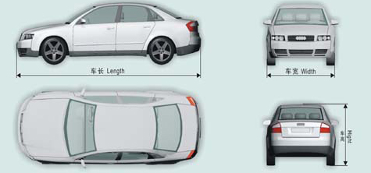

Table 2 Size and weight of the vehicles

Group Code | Vehicle length*width*height  mm*mm*mm | Weight  kg
X(small car) | ≤ 4400×1750× 1450 | ≤ 1300
Z(medium car) | ≤ 4700×1800× 1450 | ≤ 1500
D(large car) | ≤ 5000×1850× 1550 | ≤ 1700
T(outsize car) | ≤ 5300×1900× 1550 | ≤ 2350
C(oversize) | ≤ 5600×2050× 1550 | ≤ 2550
K (coach) | ≤ 5000×1850× 2050 | ≤ 1850

Before we start any design work and offer, we also need the following if possible:
who'll use the car park and with what frequency
existing infrastructure / proposed development
division of land-use
projected parking and land-use requirements
budget and timescale

Please mark the following sizes :
A:
B:
C:
D:
E:
High:

